Xingyu Huang (001582498)

**Program Structures & Algorithms**

**Fall 2021**

**Assignment No. 3**

* **Task (List down the tasks performed in the Assignment)**
* **Relationship Conclusion: (For ex : z = a * b)**

This relationship of N sites and the try-connect times is approximatly linear.

Approximate expression：

y = 10.107x - 248321

**Evidence to support the conclusion:**

**Output (Snapshot of Code output in the terminal)**

1. **Graphical Representation(Observations from experiments should be tabulated and analyzed by plotting graphs(usually in excel) to arrive on the ßrelationship conclusion)**

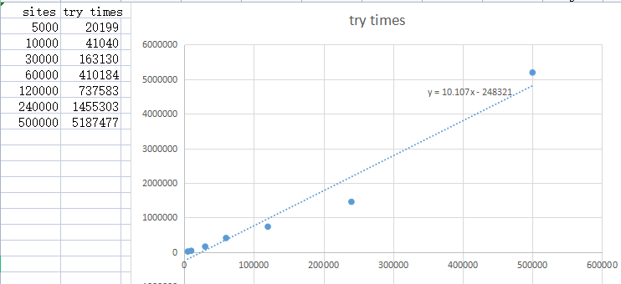

**This main function addr is：**

INFO6205-Fall2021\src\main\java\edu\neu\coe\info6205\union_find\TestUf.java

**Unit tests result:(Snapshot of successful unit tesst run)**

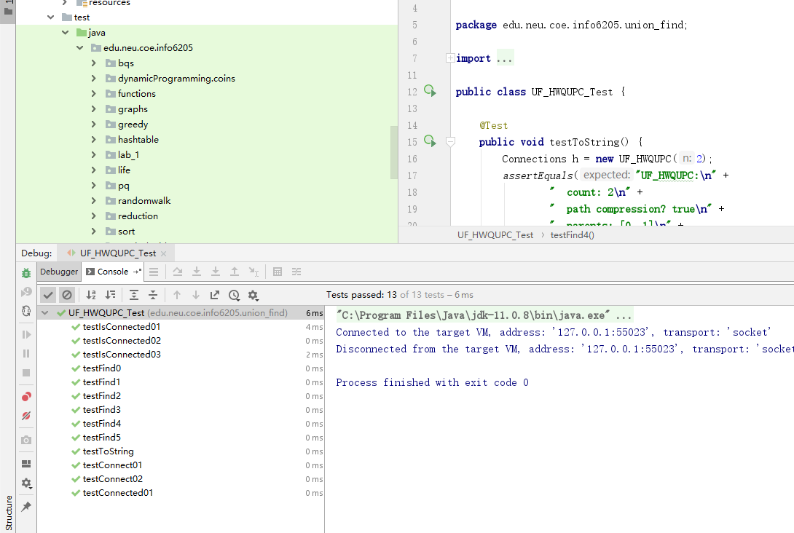

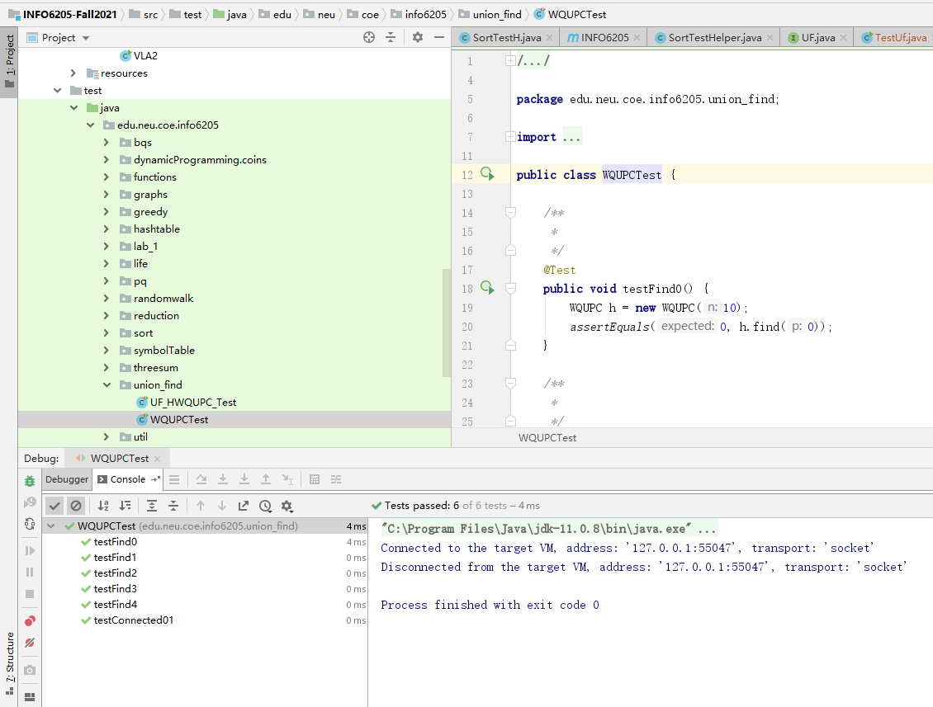

3.Your ****code**** (*RandomWalk.java* plus anything else that you changed or created);

https://github.com/XingyuHuang23/INFO_6205_Assignments